# Reverse a Number
- https://www.geeksforgeeks.org/problems/reverse-digit0316/1

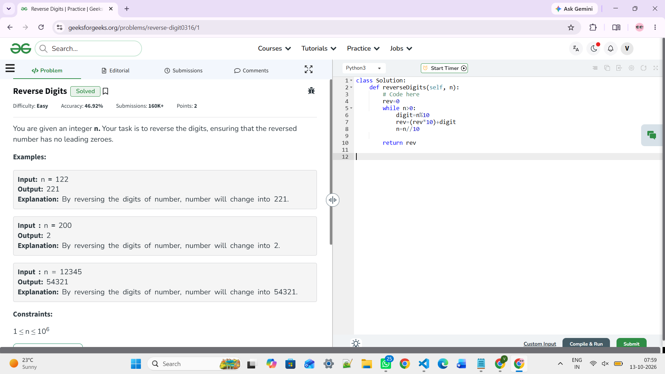

- https://leetcode.com/problems/reverse-integer/description/

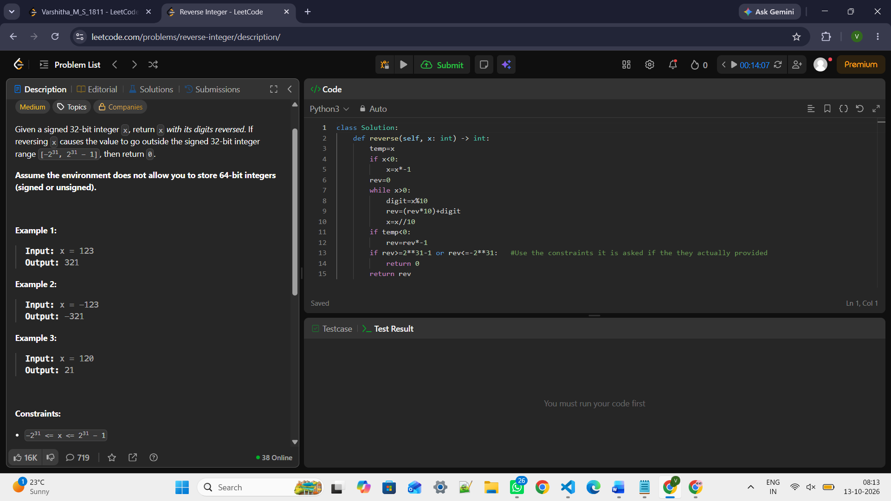

- https://www.hackerearth.com/problem/algorithm/reverse-a-number-6/

# Palindrome Number
https://leetcode.com/problems/palindrome-number/description/

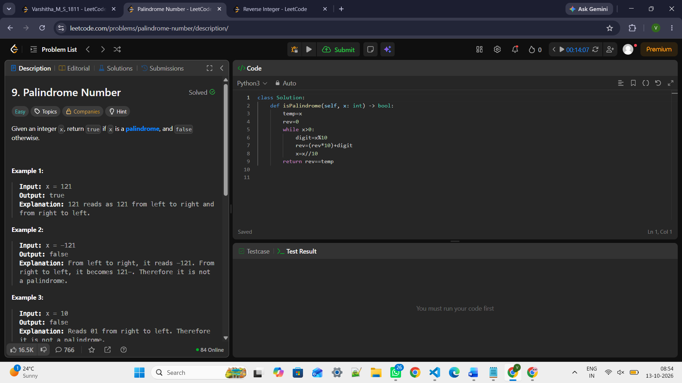

https://www.geeksforgeeks.org/problems/palindrome0746/1
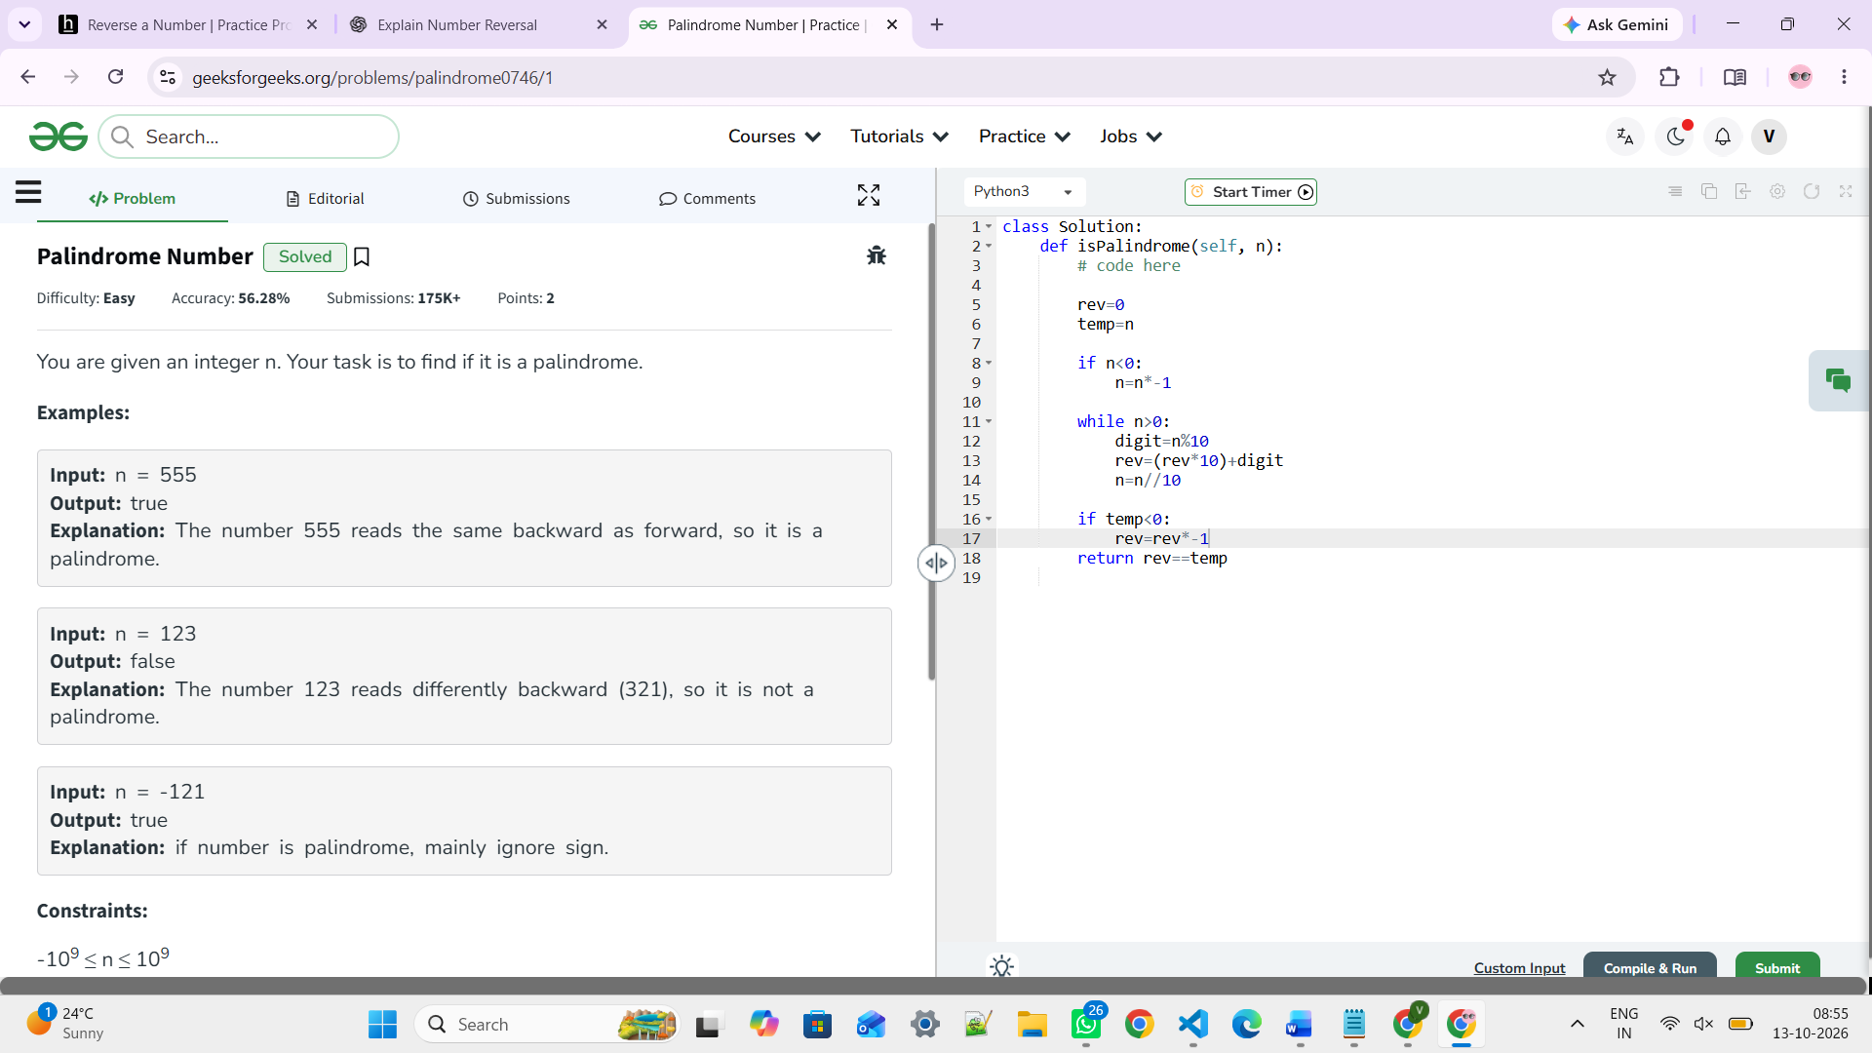

# Armstrong Number
https://www.geeksforgeeks.org/problems/armstrong-numbers2727/1
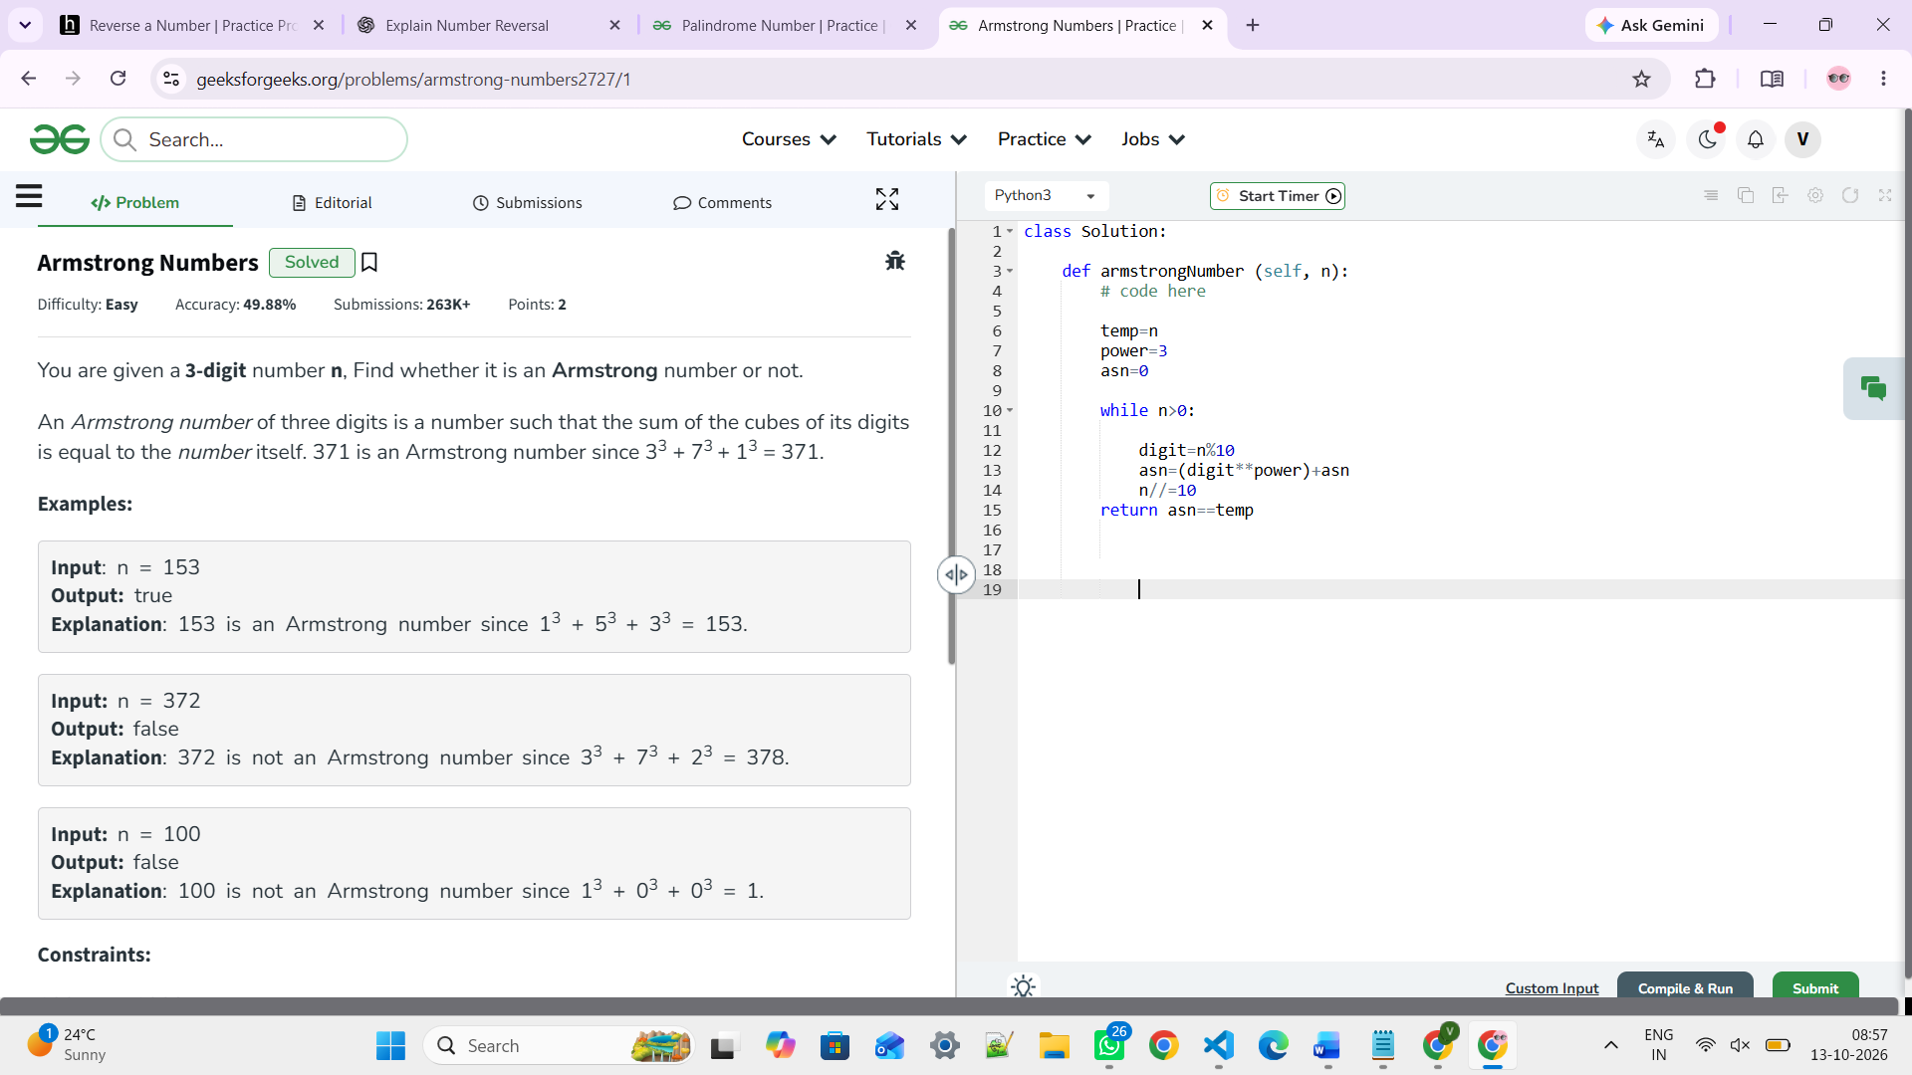

https://www.hackerrank.com/contests/iiitdm-contest1/challenges/armstrong-number-2/problem
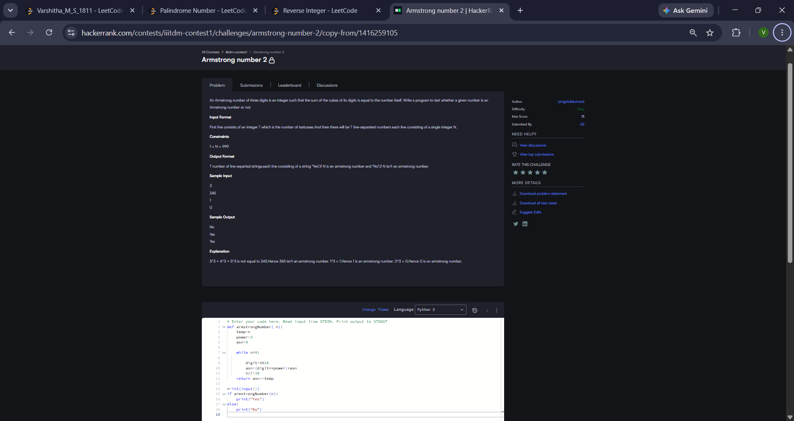

https://www.hackerearth.com/problem/algorithm/armstrong-number-12-862cf0ed/

def countDigits(n):
count = 0
while n > 0:
n = n // 10
count += 1
return count

def isArmstrong(n):
temp = n
if n < 0:
n = n * -1
asn = 0
pow = countDigits(n)

while n > 0:
digit = n % 10
asn = (digit ** pow) + asn
n = n // 10

if temp < 0:
asn = asn * -1

return asn == temp

n = int(input())
if isArmstrong(n):
print(1)
else:
print(0)

# Strong Number
https://www.geeksforgeeks.org/problems/strong-numbers4336/1
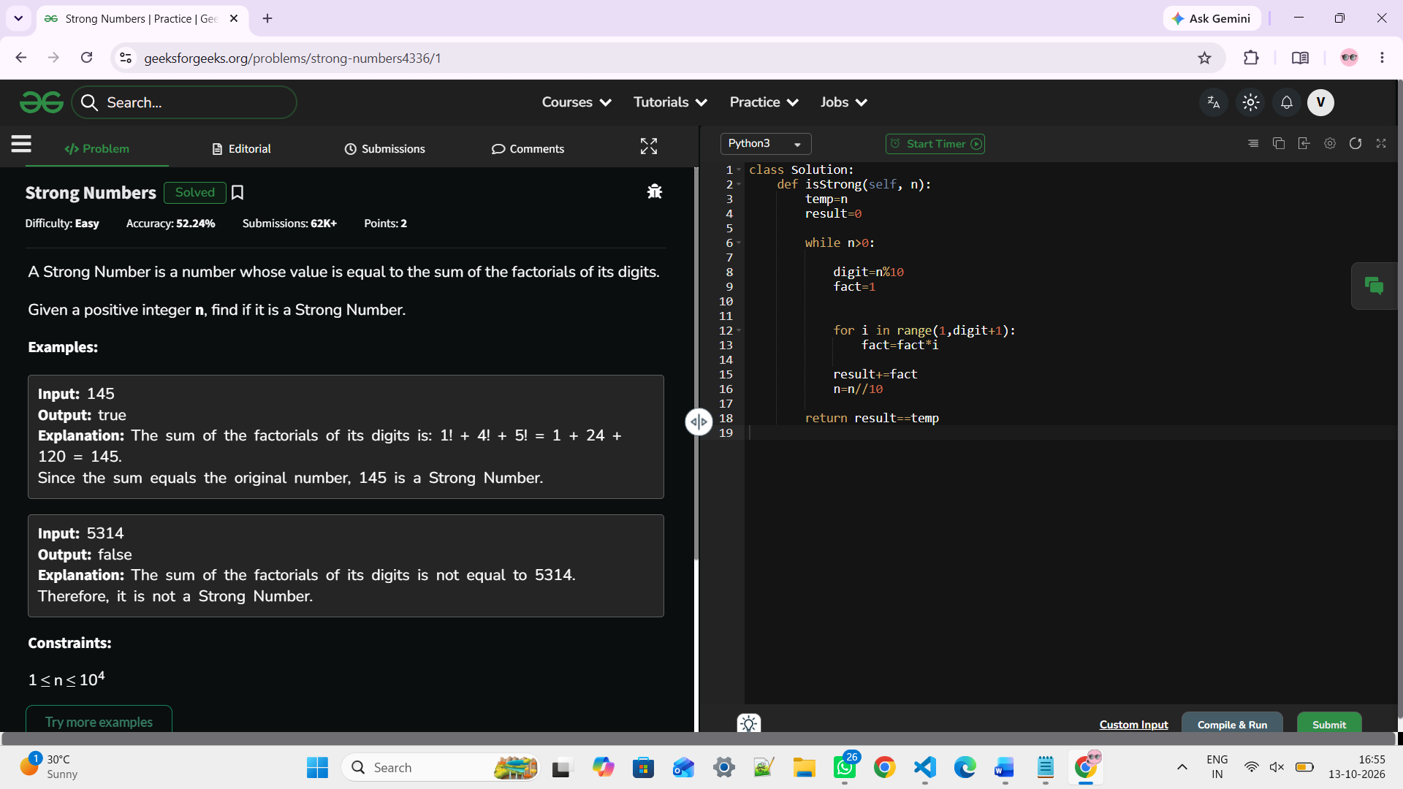

https://www.hackerearth.com/problem/algorithm/strong-number-2-e71bae03-13ed4908/

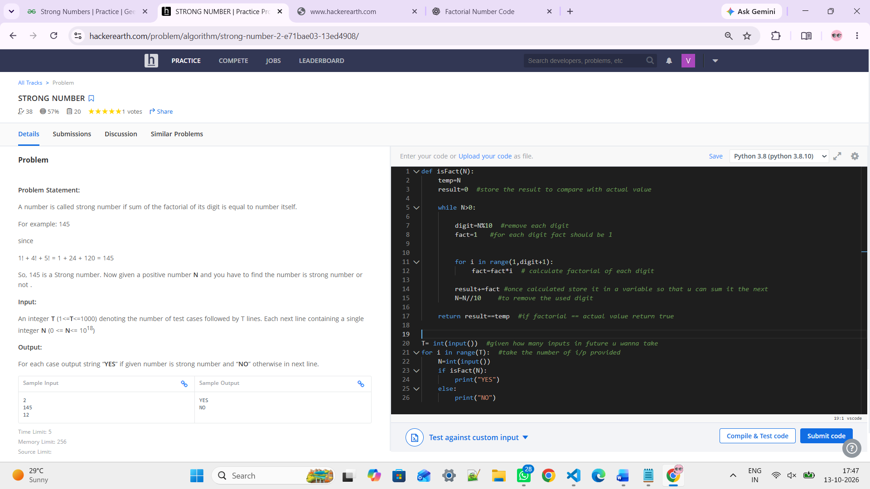

# Prime Number
https://www.hackerearth.com/practice/math/number-theory/primality-tests/practice-problems/algorithm/prime-number-6/
https://www.geeksforgeeks.org/problems/prime-number2314/1

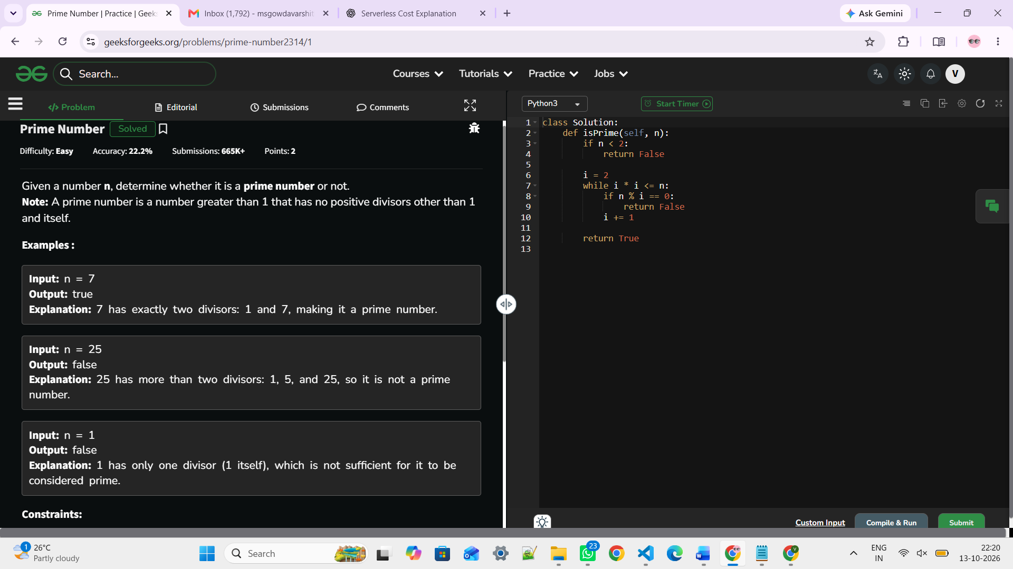

# Sum of Prime Numbers

https://www.geeksforgeeks.org/problems/sum-of-all-prime-numbers-between-1-and-n4404/1

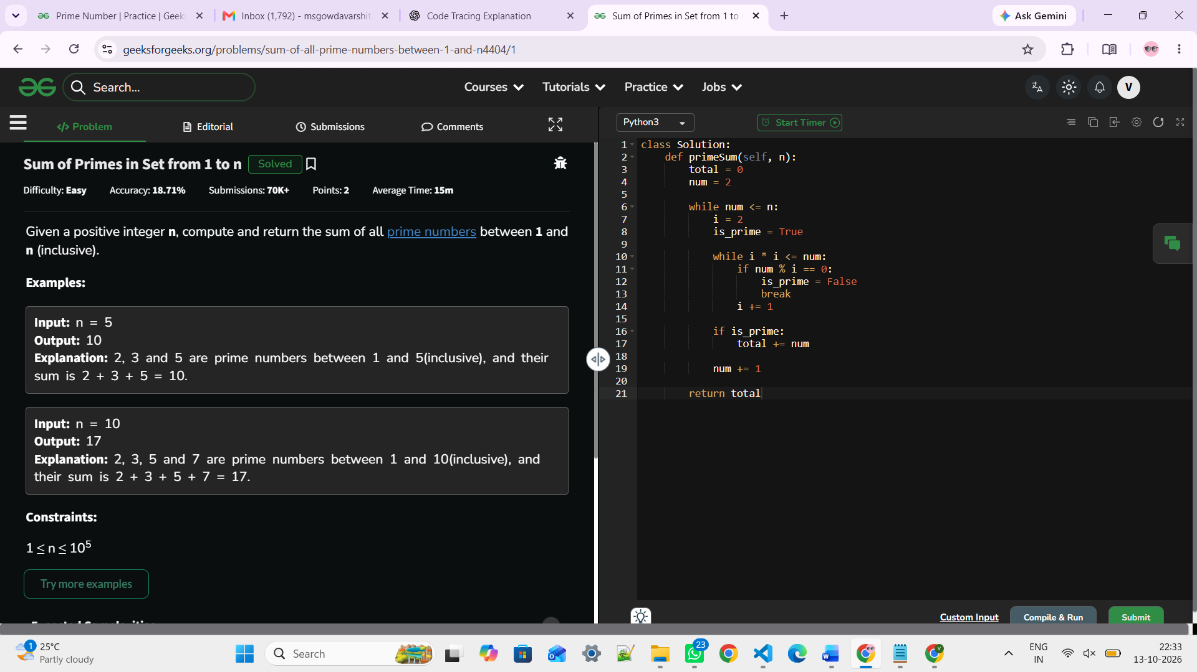

# Perfect Number
https://leetcode.com/problems/perfect-number/description/
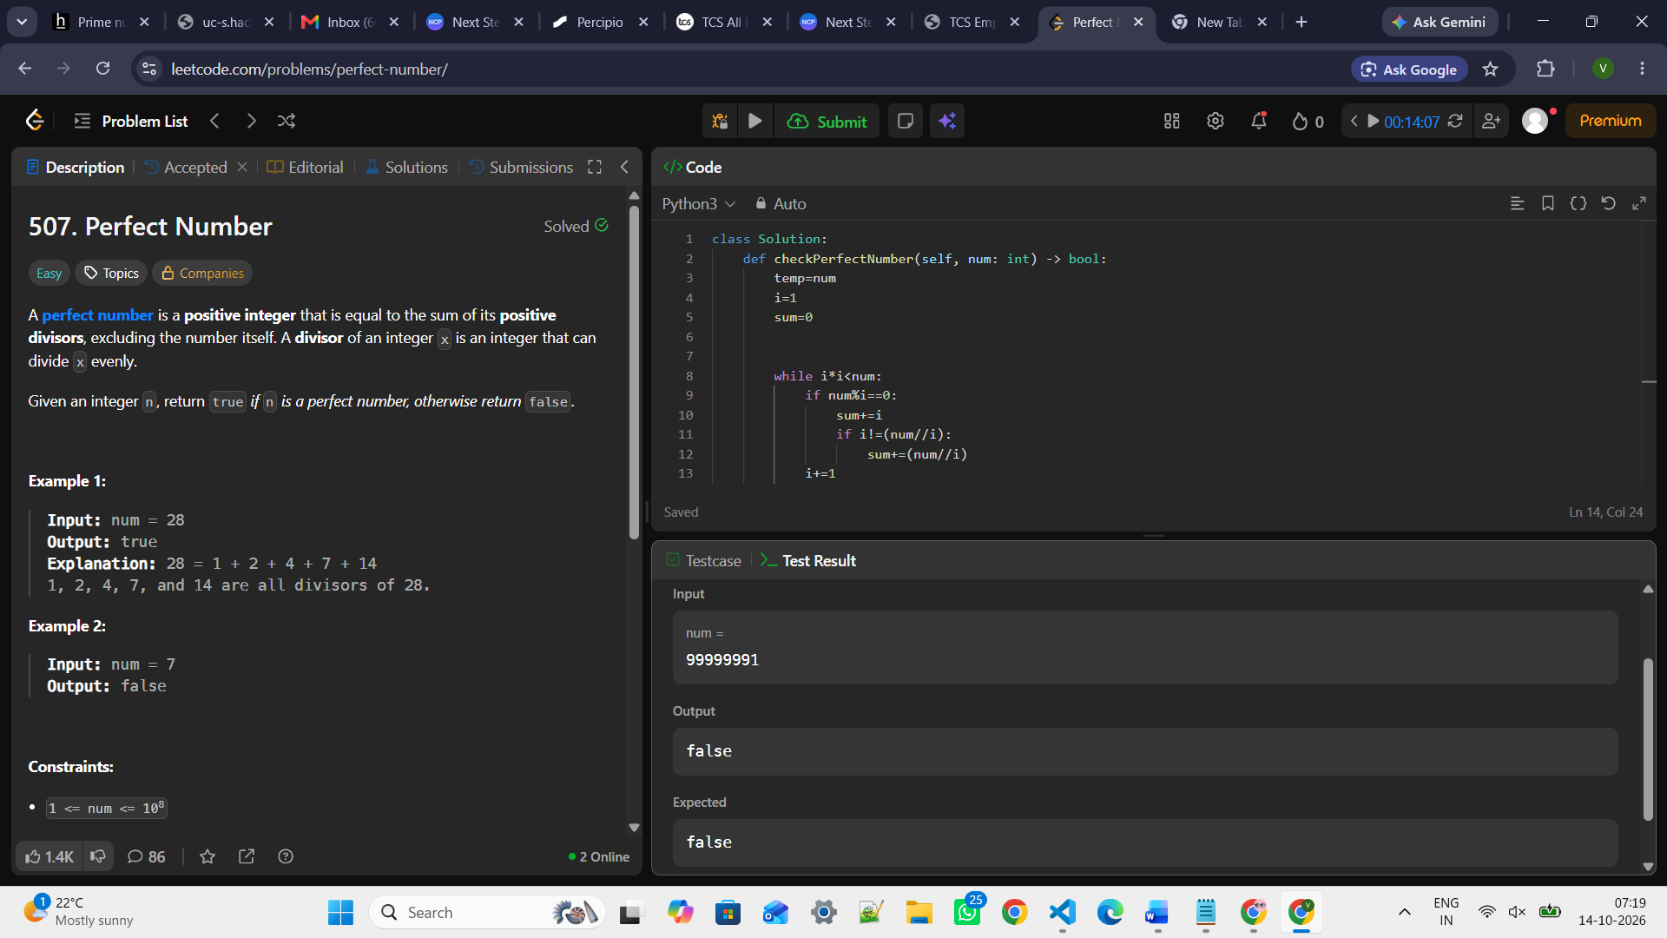

https://www.geeksforgeeks.org/problems/perfect-numbers3207/1
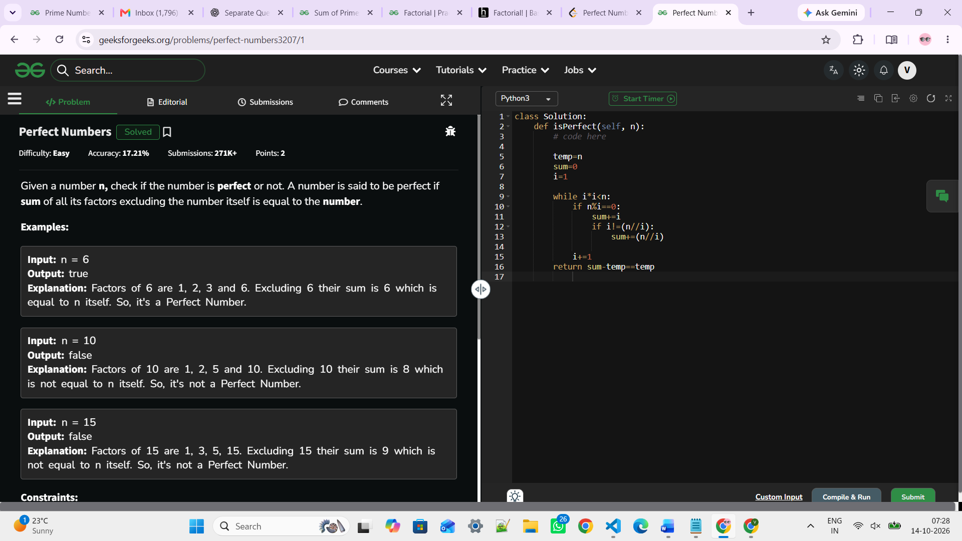

https://www.hackerrank.com/contests/codervation-4-0/challenges/check-perfect-number/problem

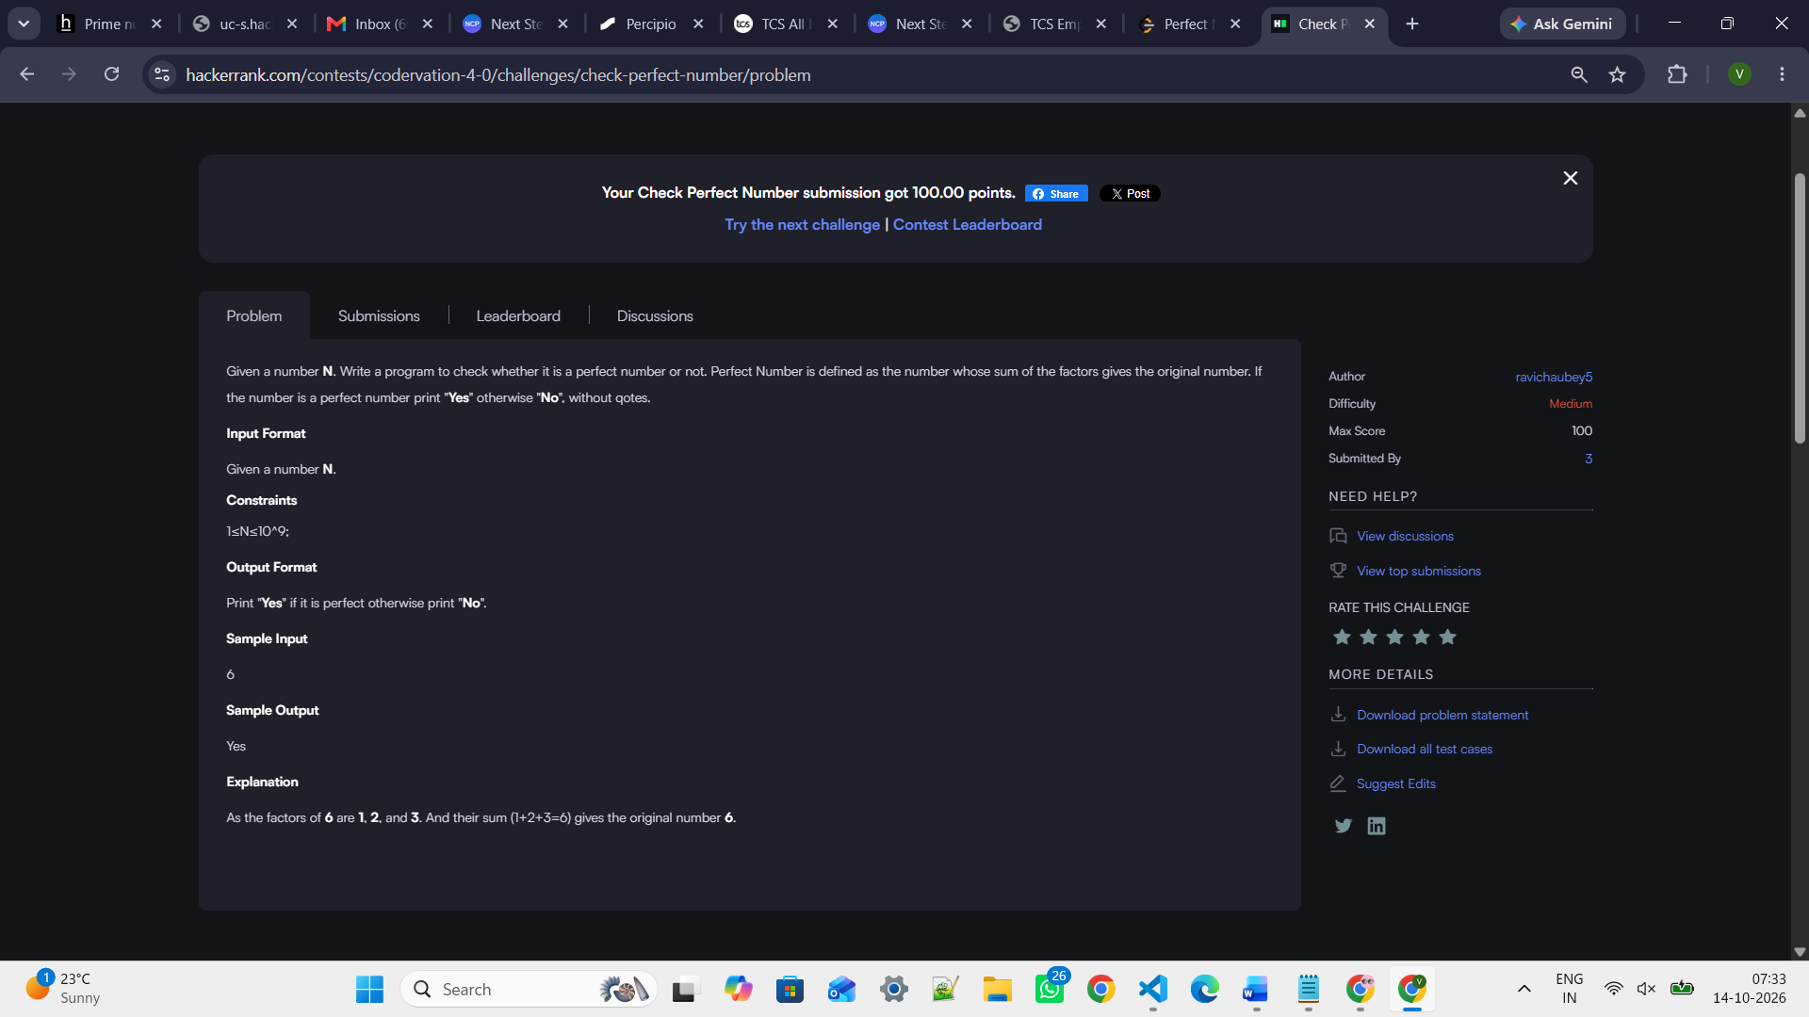

# Enter your code here. Read input from STDIN. Print output to STDOUT

def isPerfect(n):
temp=n
sum=0
i=1

while i*i<n:
if n%i==0:
sum+=i
if i!=(n//i):
sum+=(n//i)

i+=1
return sum-temp==temp

n=int(input())
if isPerfect(n):
print("Yes")
else:
print("No")

# Factorial
https://www.geeksforgeeks.org/problems/factorial5739/1
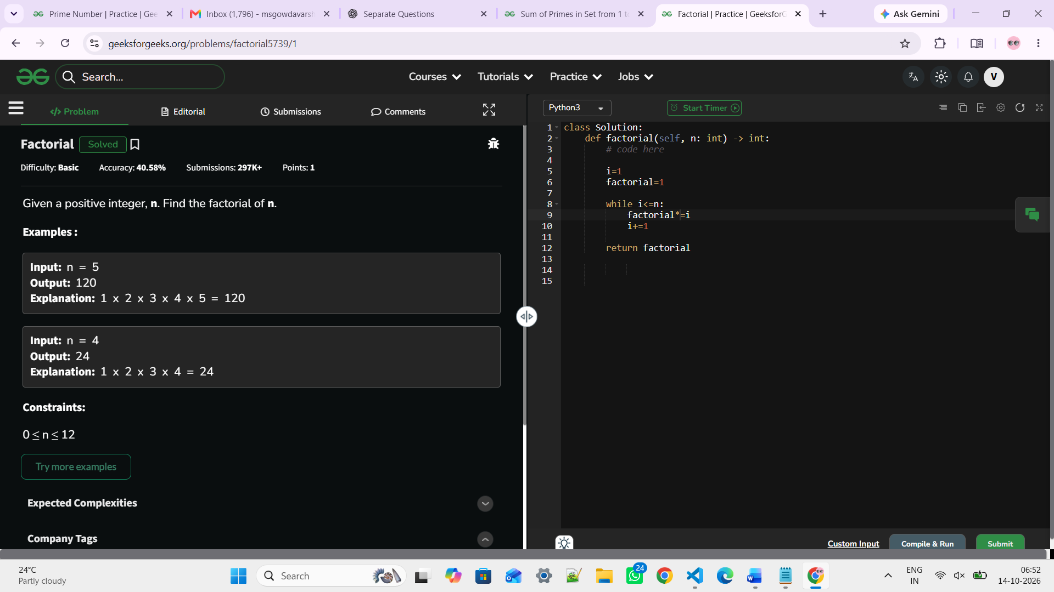

https://www.hackerearth.com/practice/basic-programming/input-output/basics-of-input-output/practice-problems/algorithm/find-factorial/
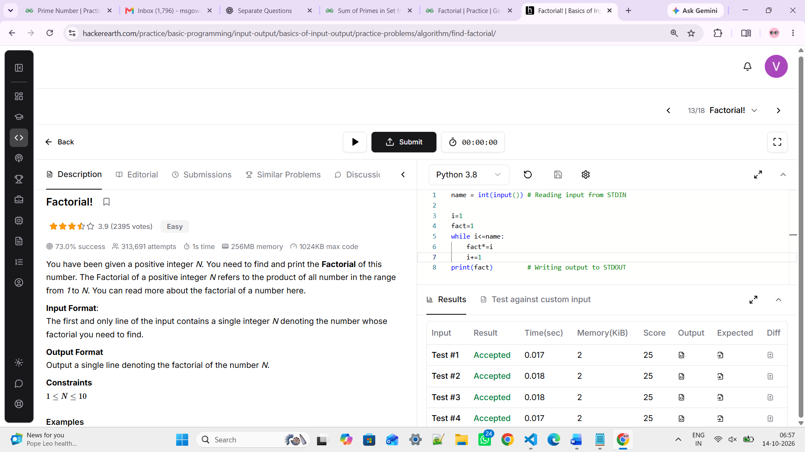
https://www.hackerearth.com/practice/basic-programming/input-output/basics-of-input-output/practice-problems/algorithm/find-factorial/

